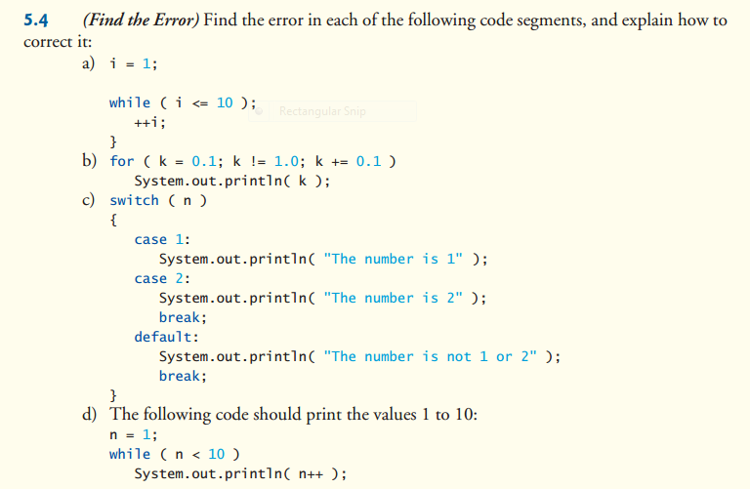

1. Infinite While Loop, not defined i
2. Cannot use float values inside for Loop, k not defined
3. The first case is missing a break causing it to print the number is both 1 and 2, n not defined
4. N not defined, Will not print 10. Should be <= 10 or < 11